Assessing organic farming practises to combat antibiotic resistance in agriculture.
Executive Summary:
5000 people die annually in the UK from antibiotic resistant bacterial infections (Alliance to save our antibiotics, 2016). This number is expected to continue to rise. The farming industry is a major consumer of antibiotics and contributes to the rise of antibiotic resistance. Research demonstrates that this extensive use of antibiotics in livestock is promoting the development of antibiotic resistance in a variety of bacteria (Figure 1). These bacteria affect not only livestock, but also humans. These spread via the food chain, from animal to animal, animal to human or deposited into the local environment via dust, manure/slurry or water courses. Antibiotics administration to livestock is less controlled and routinely administered without veterinary advice. Furthermore, in many countries antibiotics are administered to prevent diseases and to promote animal growth. In organic farming however, antibiotics are only administered as a last resort. Organic farming also promotes lower stocking levels and outdoor rearing. The proposed study aims to answer the following questions:
- Do organic farming practises lead to reduced levels of antibiotic resistance?
- What specific elements of organic farming lead to reduced antibiotic resistance?
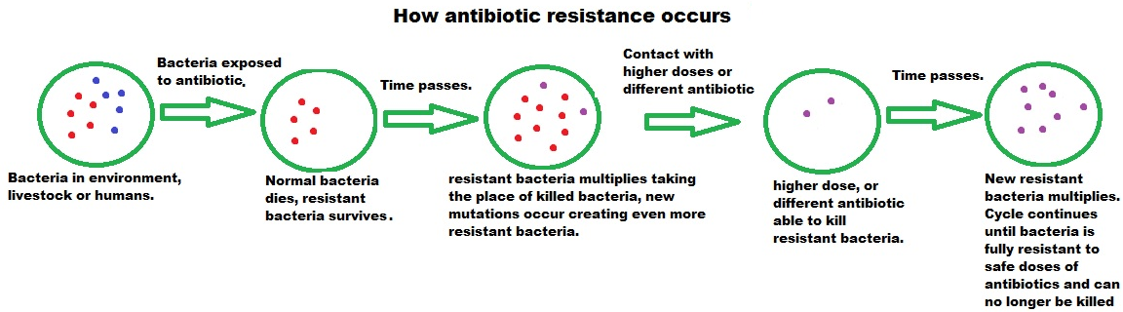
Current research has identified that organic livestock farms demonstrate reduced levels of antibiotic resistance when compared to conventional farms. Results are replicated in the USA and multiple EU countries in beef, pigs and poultry. Current data displays the possibility that factors other than levels of antibiotics administered may be involved. Recommendations are to use standardised methods on further larger scale studies, using categorised farming systems based on antibiotic intake, size and livestock density. It is also recommended that organic aspects are experimentally introduced to conventional farms to assess the impact of individual organic elements in successfully reducing antibiotic resistance. These studies should lead to affective management methods to combat antibiotic resistance escalating in agriculture. Words: 298

Figure 1 – How antibiotic resistance develops. Based on information from Public Health England (2015).

Part B:
Background and context:
Antibiotic resistance (AR) is widely accepted as a threat to humanity (WHO, 2016) as bacterial infections become increasingly difficult to treat. A range of bacteria are becoming more resistant to antibiotic treatments, including those reserved as a last resort. The alliance to save our antibiotics (2016), estimate that 5000 people die annually in the UK from antibiotic resistant bacterial infections. This number is expected to increase around the world as resistance increases.
The livestock farming industry is a major consumer of antibiotics and a contributor to AR. In the UK, antibiotics directed to livestock make up over 45% of all antibiotics administered (Alliance to save our antibiotics, 2016). Evidence demonstrates that extensive use of antibiotics in livestock is promoting the development of AR in a variety of bacteria (Farmers weekly, 2016). These resistant bacteria or resistant genes are not only able to spread between animals but some, such as antibiotic resistant E.coli, can also be zoonotic. Spread occurs via direct contact, through the food chain and into the environment via farm water discharges (Tao et al., 2014), dust (McEachran et al., 2015) and manure spreading (Zhou et al., 2016).
Antibiotics administered to livestock are mostly unrestricted and routinely administered without veterinary advice. Furthermore, in many countries antibiotics are administered prophylactically and subclinically as growth promoters. A letter signed by 15 senior medics including the presidents of the Royal Society of Medicine and the British Medical Association was sent to the UK government in November 2016 demanding urgent action to reduce the use of antibiotics in agriculture (Farmers Weekly, 2016).
In contrast to conventional farming, organic farms administer antibiotics only as a last resort (European Commission, 2017). Organic farming also promotes lower stocking levels and outdoor rearing. This research project aims to assess whether organic farming practices can play a role in slowing the proliferation of AR. The research will be based on answering the two questions:
- Do organic farming practises lead to reduced levels of antibiotic resistance?
- What specific elements of organic farming lead to reduced antibiotic resistance?
Research by Osterberg et al. (2016) investigated levels of AR in Escherichia coli from pigs in conventional and organic farms in Denmark, France, Sweden and Italy. Another study by Zwonitzer et al. (2016) was performed on pigs in the USA. Both studies highlight significant lower levels of resistance to a number of antibiotics in the organic farms over their conventional counterparts. Plot 1 and 2 exhibit the results. The results also demonstrate national variations. For example French results showed little difference in Ampicillin resistance between organic and conventional farms. It must be noted that Ampicillin resistance in conventional farm in France is also low.

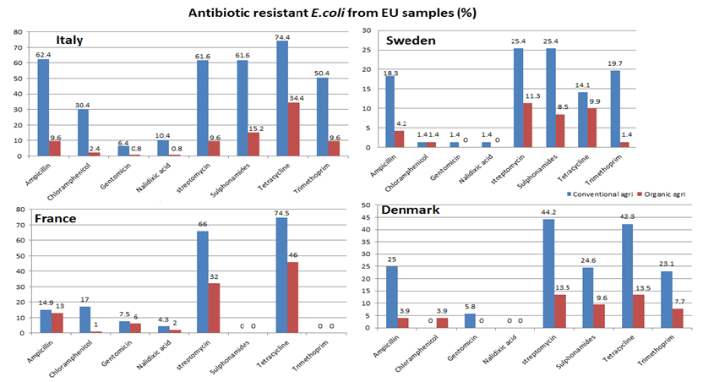

Plot 1 - % of sampled E.coli showing resistance to individual antibiotics. Derived from raw data by Osterberg et al. (2015).
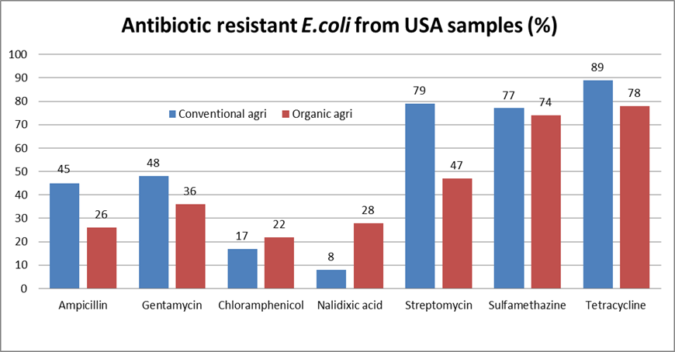

Plot 2 - % of sampled E.coli showing resistance to individual antibiotics. Derived from raw data by Zwonitzer et al. (2016).

Sapkota et al. (2014) investigated US poultry farms to ascertain if farms that had made a move to organic demonstrated lower levels of antibiotic resistance. Samples taken from newly organic farms showed significant lower levels of Salmonella resistance to a number of antibiotics and multi-drug therapies. Results showed in plot 3. These results are interesting as they demonstrate that potentially, levels of resistance can drop quickly as antibiotic use is reduced.
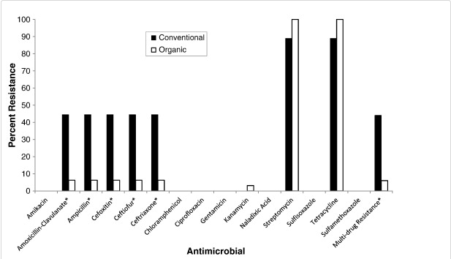

Plot 3 - % of sampled Salmonella showing resistance to individual antibiotics and multi-drug treatments (Sapkota et al., 2014, p390).
A further study by Sancheza et al. (2016) measured antibiotic resistance in airborne bacteria around conventional and organic beef farms in California. This study also found lower levels of resistance to antibiotics such as Penicillin, Cloxacillin, Cefoperazone and Sulfamethazine from samples taken downwind of organic farms over their conventional counterparts. Plot 4 shows some key results.
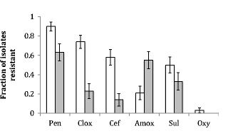

Plot 4 – Fraction of isolates showing resistance to antibiotics; Hollow bars from conventional farms, filled bars from organic farms (Sancheza et al., 2016, p 5).

These studies demonstrate that AR can be lower in organic farming systems rearing pigs, beef and poultry. The study by Snapkota et al. (2014) also demonstrates that levels of resistance can drop when organic practises are adopted. The studies span 5 countries (spread across various regions and states of each country). The results show that organic farming practices lower AR in all nations studied. This is interesting as levels of antibiotics administered in Europe are much lower due to stricter regulations in comparison to the USA. This similarity in results between the US and EU countries demonstrates that aspects of organic farming other than levels of antibiotics administered may play an important part. For example, lower stocking levels and outdoor rearing can help reduce the spread of infections in livestock; reducing proliferation of AR genetic mutations. The variation in AR between EU countries, who follow the same regulations, could also point towards other aspects involved in reduced resistance.
Research by Zhou et al. (2016) and Wichmann et al. (2014) show some evidence however that the increasing spread of manure and slurry on crop in organic arable farms increase the spread of antibiotic resistant bacteria into the environment. This is an aspect of organic farming, possibly amongst others, that was not taken into account in other studies.
Scoping exercise to suggest future research:
Although thorough, the primary research is still limited. No other studies other than the research stated in this report were found making direct comparisons between organic and conventional farming practices. Also all studies were relatively small. For example the study by Sancheza et al. (2016) concentrated on 6 farms. There is currently not enough evidence to be able to generalise the results. The first development research goal would be to:
- Expand on the current data set by carrying further research using more farms across wider geographical regions and countries.
More extensive research and data sets available to study would make sure that the results found so far were valid across farms, regions, climates and countries.
Whilst it is assumed that organic farms will use lower amounts of antibiotics, there is currently no data on antibiotic administration differences between farms. As mentioned before, antibiotic administration between countries will differ due to variations in legislations. This could mean that the differences between organic and conventional farms may differ in different countries. There may also be variations between farms in the same countries. Some farms, whilst not organic, may decide to limit antibiotics, to follow best practice as prescribe by agricultural organisations such as the AHDB (Agricultural and Horticultural Development Board). In the same vein, some conventional farms may decide to have lower stocking densities and make best use of outdoor space. These are all important variables and therefore the second development research goal would be to:
- Classify farms to be used in future studies into groups based on levels of antibiotics used and stocking levels & density.
There is a wide spectrum of farm sizes and operational systems ranging from full intensive factory farming to fully organic. Such a classification system will ensure results obtained are reliable. Such a system will also help in identifying trends across all farming systems.
The evidence so far does suggest reduced levels of antibiotic resistance in organic farms, however there is currently no evidence or research into what aspect or aspects of organic farming are the key reasons for these results. This makes the third development research goal to:
- Research individual elements of organic farming to ascertain the specific factors that most affect levels of antibiotic resistance.
Whilst not all farms are willing or able to become organic, they may be willing to incorporate certain aspects into their current farming system to reduce the rates of AR. It may also help highlight any previously unforeseen negative effect of organic farming, such as the use of organic manures in arable farms.
Research methods:
The studies assessed so far give in depth and clear accounts of their research methods. All use similar methods. Samples of bacteria are collected from organic and conventional farms and then grown in Agar plates laced with specific antibiotics. Growth of the bacteria in the presence of the antibiotics indicates antibiotic resistance. Some of the studies such as Sancheza et al. (2016) not only assess bacterial growth but also the presence of specific known antibiotic resistant genes. Individually the techniques are sound and widely accepted. The problem arises however when trying to compare results. Whilst similar, each study had slight variations in the methods. Samples were collected from different parts. Some samples were collected directly from the animal guts, others from dust and some from manure. Different studies concentrated on different bacteria, some studied e.coli whilst others studied salmonella for example. Different animals were used. In the smaller details, different minimum inhibitory concentrations (MIC) referenced tables were used. Whilst these differences provide a wide range of preliminary data, further studies should use standardised methods to allow for direct comparisons. Such possible comparisons would include regions and, if enough samples are taken, between bacteria and also antibiotics. As stated previously, classifying farms based on size and farming methods would also allow more valid comparisons and create a new data set for study. This kind of standardised study could prove difficult however, as researchers from numerous countries would have to agree to take on the study and agreeing on the standards to be used may be problematic across borders.
Samples in each study were limited to a handful of farms and so a larger sample size across countries is required. The larger the sample size, the higher the validity of the study. Limiting factors to increased sample sizes would be availability of researchers and costs involved. Finding willing farms may also be difficult as some farms, especially those with very intensive production systems, may be unwilling to give access.
Finally, controlled experiment designs could be used. These have not yet been performed to study AR in organic farming. Specific aspects of organic farming can be introduced to non-organic farms in controlled experiments. This could demonstrate what key factors in organic farming can lead to reduced AR. The downfall to such a study would be the time required for results; although the study by Sapkota et al. (2014) show that results may occur fairly quickly. Finding willing farms may again prove challenging and may require financial incentives.

Risks and ethical aspects:
The risks associated with performing this study are low with no ethical issues identified. Collecting and handling samples would require only basic PPE and standard risk assessments. Nothing is being introduced that could have any health (human and animal) or environmental implications. As far as trialling organic elements in conventional farming, these elements are widely accepted as best practise in agriculture, and therefore would pose no risk or raise any ethical issues.
The risks of not continuing along this avenue of research are however high. Antibiotic resistance has been described by the WHO (2016) as one of the greatest threats to human health. Increased AR in livestock could have grave economic impacts on the farming industry as livestock fail to reach full potential, or die due to untreatable diseases. Future outbreaks could decimate livestock. This could impact the Uk’s and the world’s food security. Major outbreaks in livestock could go untreated, and the economic burden on farmers could see food supplies in the UK and the world seriously affected, leading to a world food shortage.
AR in agriculture is contributing to AR in human healthcare. In the future, AR is expected to cost countless lives. Not pursuing research avenues that could alleviate or prevent these problems could be considered high risk and raises ethical issues.
Conclusion to report and key scientific recommendations for future funding:
Antibiotic resistance is a threat to health and our current way of life. Antibiotic use in agriculture is a major contributor to this threat. Current research data illustrates that organic farming systems may help reduce antibiotic resistance proliferation. Some research however, has shown that the spread of organic livestock waste may increase levels of antibiotic resistance in arable farms. Further international data collection, using standardised methods (including classification system for farms) would lead to valid and reliable data allowing for true comparisons between countries and farming systems. The study of organic orientated practices carried out in conventional farms may identify what specific aspects of organic farming are behind reduced level of antibiotic resistance. This research could lead to concrete solutions implementable to all farms. Inaction could lead to economic instability, food shortages and increased mortality in humans.

Glossary:
Antibiotic: An agent (artificial or natural), that can be used as medicine, that destroys or inhibits growth of an organism. The term is usually reserved for bacterial organisms.
Antibiotic resistance (AR): The ability of bacteria to survive therapeutic levels of antibiotics, making treatment of infection difficult or impossible without damaging the host.
Agar: A growth medium that allow organisms such as bacteria to grow in laboratory conditions.
Arable: Farming system that produces crops.
Genetic mutation: An umbrella term that includes various events that change the gene expression in an organism. This is the driving force behind evolution and antibiotic resistance.
Manure: Solid livestock waste consisting of straw and animal excrement.
Minimum inhibitory concentration: Minimum amount of a substance required to prevent growth of an organism. An organism able to grow beyond the MIC are said to be resistant.
Organic: Farming system that aim to operate as natural as possible, with as little environmental impact and high animal welfare. Use of antibiotics and other chemicals is strictly limited, food is natural with no genetically modifications, and outdoor space is preferred, with low stock numbers.
Prophylactically: The process of giving medication prior to any signs of ill health to prevent ill health from occurring.
Resistant gene: Genes present in bacteria that code for proteins that will help the bacteria combat antibiotics.
Slurry: Liquid livestock waste consisting of animal excrement.
Subclinical: Dosage of medication below amounts required to have a therapeutic effect.
Zoonotic: Any diseases that can be passed from vertebrate animals to humans.

References:
Alliance to save our antibiotics (2016) Welcome Page [Online]. Available at http://www.saveourantibiotics.org/ (Accessed 11 May 2017).
European Commission (2017) Agricultural and rural development – organic farming [Online]. Available at https://ec.europa.eu/agriculture/organic/eu-policy/eu-rules-on-production/livestock_en (Accessed 10 May 2017).
Farmers Weekly (2016) Doctors call for ban on farm antibiotics [Online]. Available at http://www.fwi.co.uk/livestock/doctors-call-ban-farm-antibiotics.htm (Accessed 11 May 2017).
McEachran, A., Blackwell, B., Hanson, D., Wooten, K., Mayer, G., Cox, S., Smith, P. (2015) ‘Antibiotics, Bacteria, and Antibiotic Resistance Genes: Aerial Transport from Cattle Feed Yards via Particulate Matter’, Environmental health perspectives, vol. 123, issue 4, pp. 337-343, [Online]. Available at https://www.ncbi.nlm.nih.gov/pmc/articles/PMC4383574/ (Accessed 10 May 2017).
Osterberg, J., Wingstrand, A., Jensen, A., Kerouanton, A, Cibin, V., Barco, L., Denis, M., Aabo, S., Bengtsson, B. (2016) ‘Antibiotic Resistance in Escherichia coli from Pigs in Organic and Conventional Farming in Four European Countries ’, PLOSone, vol. 11, issue 6, [Online]. Available at (http://journals.plos.org/plosone/article?id=10.1371/journal.pone.0157049 (Accessed 10 May 2017).
Public Health England (2015) Health matters: antimicrobial resistance [Online]. Available at https://www.gov.uk/government/publications/health-matters-antimicrobial-resistance/health-matters-antimicrobial-resistance (Accessed 18 May 2017).
Sancheza, H., Echeverria, C., Thulsiraj, V., Zimmer-Faust, A., Flores, A., Laitz, M., Healy, G., Mahendra, S., Paulson, S., Zhu, Y., Jay, J. (2016) ‘Antibiotic Resistance in Airborne Bacteria Near Conventional and Organic Beef Cattle Farms in California, USA’,Water Air Soil Pollution, vol.227, issue 280, [Online]. Available at https://link-springer-com.libezproxy.open.ac.uk/article/10.1007/s11270-016-2979-8 (Accessed 10 May 2017).
Sapkota, A., Kinney, E., George, A., Hulet, R., Cruz-Cano, R., Schwab, K., Zhang, G., Joseph, S. (2014) ‘Lower prevalence of antibiotic-resistant Salmonella on large-scale U.S. conventional poultry farms that transitioned to organic practices’, Science of the Total Environment, vol. 476-477, pp. 387-392, [Online]. Available at http://www.sciencedirect.com.libezproxy.open.ac.uk/science/article/pii/S0048969713014575 (Accessed 10 May 2017).
Tao, C., Hsu, B., Ji, W., Hsu, T, Kao, P., Hsu, C., Shen, S., Shen, T., Wan, T., Huang, Y. (2014) ‘Evaluation of five antibiotic resistance genes in wastewater treatment systems of swine farms by real-time PCR ’,Science of the Total Environment, vol. 496, pp. 116-121, [Online]. Available at http://www.sciencedirect.com.libezproxy.open.ac.uk/science/article/pii/S0048969714010390 (Accessed 10 May 2017).
Wichmann, F., Udikovic-Kolic, N., Andrew, S., Handelsman, J. (2014) ‘Diverse Antibiotic Resistance Genes in Dairy Cow Manure’, mBio, vol. 5, issue 2, [Online]. Available at http://mbio.asm.org/content/5/2/e01017-13 (Accessed 10 May 2017).
World Health organisation (2016) Antibiotic resistance [Online]. Available at http://www.who.int/mediacentre/factsheets/antibiotic-resistance/en/ (Accessed 11 May 2017).
Zhou, X., Qiao, M., Wang, F., Zhu, Y. (2016) ‘Use of commercial organic fertilizer increases the abundance of antibiotic resistance genes and antibiotics in soil’, Environmental Science and Pollution Research, vol. 24, issue 1, pp. 701-710, [Online]. Available at https://link-springer-com.libezproxy.open.ac.uk/article/10.1007/s11356-016-7854-z (Accessed 10 May 2017).
Zwonitzer, M., Soupir, M., Jarboe, L., Smith, D. (2016) ‘Quantifying Attachment and Antibiotic Resistance of Eschrichia coli from Conventional and Organic Swine Manure’, Journal of Environmental Quality, vol. 45, issue 2, pp. 609–617 [Online]. Available at https://dl.sciencesocieties.org/publications/jeq/abstracts/45/2/609 (Accessed 10 May 2017).

*Zwonitzer et al. (2016), Osterberg et al. (2016) and European Commission (2017) previously used in poster for tma03 so not underlined.

